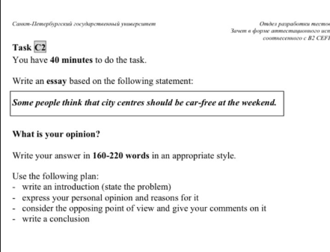

Some people think that city centers should be car-free at the weekend

Nowadays, more and more people are thinking about freeing the central streets of cities from cars in order to enable pedestrians to walk freely and safely. I think that it would be great to free city centers from cars at least at the weekend.

The first is that it improves the safety of people. On weekends, such places are especially crowded with people and tourists, so heavy traffic on the roads can be dangerous for both drivers and pedestrians. Obviously, if we reduce traffic or completely free the center from cars, pedestrians will feel more comfortable.

Moreover, most often in the historical center the streets are quite narrow, and because of the cars the pedestrian zone becomes very small, so they cannot relax and enjoy the architectural monuments. In such places cars are a source of noise and anxiety, which negatively affects people's mood.

In spite of my own opinion, many people think that blocking streets will create traffic jams. In addition, it will interfere with the operation of emergency services.

To sum up, I support the idea of making city centers car-free at the weekends, because

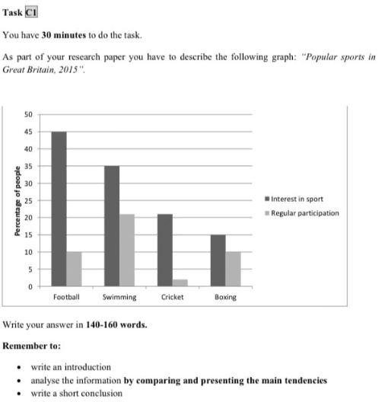

The chart provides us information about popular sports in Great Britain in 2015.

 We can notice that almost half of British people are interested in football. But only every tenth of the respondents actually play football. Despite the fact that the second most popular sport is swimming, the number of swimmers is twice as many as football players.

Overall, huge number of people are interested in sports, but the graph shows that the number of people involved in sports is always less than those who simply follow it.

The chart provides us information about popular sports in 2015 in Great Britain.

Overall, the chart shows that a lot of people are interested in sports. However, not everyone is a regular participant.

We can notice that almost half of british people are interested in football. But only every tenth of the respondents actually play football.

Despite the fact that the second most popular sport is swimming, the number of swimmers is twice as many as football players. Another notable kind of sport is cricket.

More than 20% of respondents are fascinated by it. It is a wonder that less than 5% of them turned up to be a regular participant. But the situation is radically different with boxing. Almost everyone who interested in it are in fact a sportsman.

To describe some striking features of the graph